**IF-ELSE-ELIF STATEMENTS**

There comes situations in real life when we need to make some decisions and based on these decisions, we decide what we should do next. Similar situations arise in programming also where we need to make some decisions and based on these decisions we will execute the next block of code. Decision-making statements in programming languages decide the direction of the flow of program execution.

In Python, an if-else-elif statement is used for decision making.

## **if statement**

if statement is the most simple decision-making statement. It is used to decide whether a certain statement or block of statements will be executed or not i.e if a certain condition is true then a block of statement is executed otherwise not.

**Syntax**:

if *condition*:

# Statements to execute if

# condition is true

Here, the condition after evaluation will be either true or false. If statement accepts boolean values – if the value is true then it will execute the block of statements below it otherwise not. We can use the condition with bracket ‘(‘ ‘)’ also.

As we know, python uses indentation to identify a block. So the block under an if statement will be identified as shown in the below example:

if condition:

statement1

statement2

# Here if the condition is true, if block

# will consider only statement1 to be inside

# its block.

## **Flowchart of Python if statement**

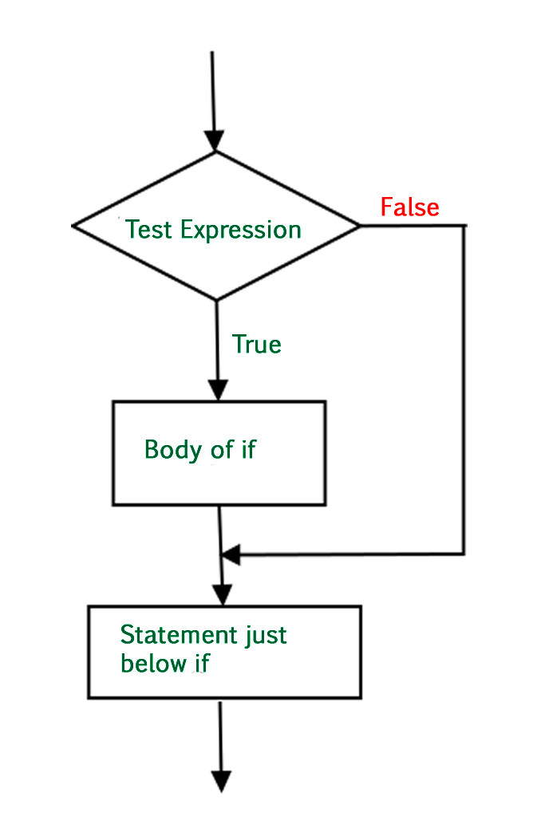

### **Example: Python if Statement**

* Python3

| # python program to illustrate If statement    i = 10    if (i > 15):  print("10 is less than 15")  print("I am Not in if") |
| --- |

**Output:**

I am Not in if

As the condition present in the if statement is false. So, the block below the if statement is not executed.

## **if-else**

The if statement alone tells us that if a condition is true it will execute a block of statements and if the condition is false it won’t. But what if we want to do something else if the condition is false. Here comes the *else* statement. We can use the *else* statement with *if* statement to execute a block of code when the condition is false.

**Syntax**:

if (condition):

# Executes this block if

# condition is true

else:

# Executes this block if

# condition is false

## **FlowChart of Python if else statement**

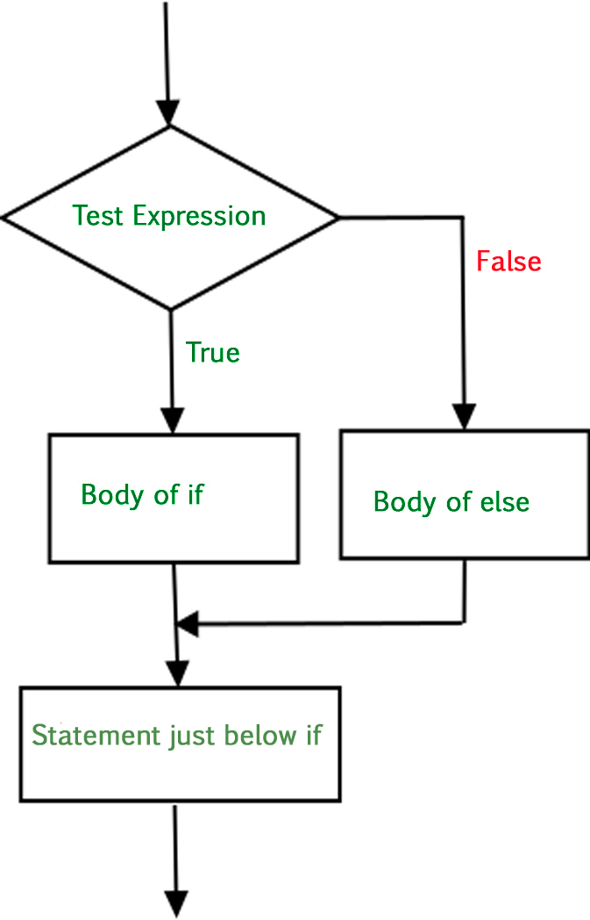

### **Example 1: Python if else statement**

* Python3

| # python program to illustrate If else statement    i = 20  if (i < 15):  print("i is smaller than 15")  print("i'm in if Block")  else:  print("i is greater than 15")  print("i'm in else Block")  print("i'm not in if and not in else Block") |
| --- |

**Output:**

i is greater than 15

i'm in else Block

i'm not in if and not in else Block

The block of code following the else statement is executed as the condition present in the if statement is false after calling the statement which is not in the if block(without spaces).

---------X------------------X-----------

List comprehension is a concept that involves both , the for loop and if-else concepts, so it can be skipped until after the for loop has been taught.

-----------X-----------X-----------------X

### **Example 2: Python if else in list comprehension**

* Python3

| # Explicit function  def digitSum(n):  dsum = 0  for ele in str(n):  dsum += int(ele)  return dsum      # Initializing list  List = [367, 111, 562, 945, 6726, 873]    # Using the function on odd elements of the list  newList = [digitSum(i) for i in List if i & 1]    # Displaying new list  print(newList) |
| --- |

**Output**

[16, 3, 18, 18]

## **nested-if**

A nested if is an if statement that is the target of another if statement. Nested if statements mean an if statement inside another if statement. Yes, Python allows us to nest if statements within if statements. i.e, we can place an if statement inside another if statement.

**Syntax**:

if (condition1):

# Executes when condition1 is true

if (condition2):

# Executes when condition2 is true

# if Block is end here

# if Block is end here

## **Flowchart of Python Nested if Statement**

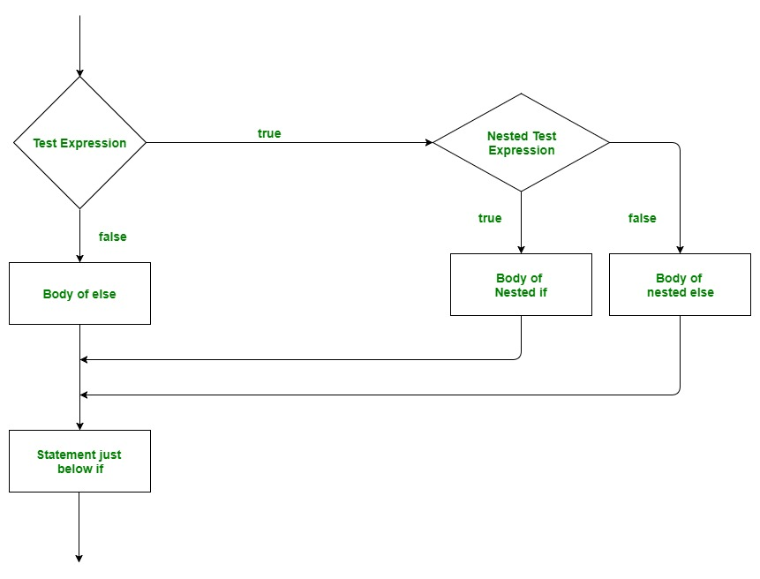

### **Example: Python Nested if**

* Python3

| # python program to illustrate nested If statement  #!/usr/bin/python  i = 10  if (i == 10):    # First if statement  if (i < 15):  print("i is smaller than 15")    # Nested - if statement  # Will only be executed if statement above  # it is true  if (i < 12):  print("i is smaller than 12 too")  else:  print("i is greater than 15") |
| --- |

**Output:**

i is smaller than 15

i is smaller than 12 too

## **if-elif-else ladder**

Here, a user can decide among multiple options. The if statements are executed from the top down. As soon as one of the conditions controlling the if is true, the statement associated with that if is executed, and the rest of the ladder is bypassed. If none of the conditions is true, then the final else statement will be executed.

**Syntax**:

if (condition):

statement

elif (condition):

statement

.

.

else:

statement

## **FlowChart of Python if else elif statements**

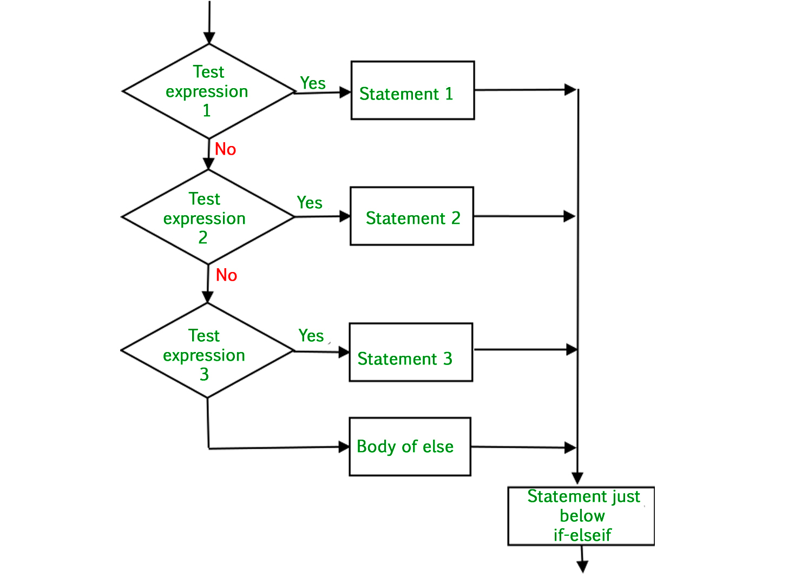

### **Example: Python if else elif statements**

* Python3

| # Python program to illustrate if-elif-else ladder  #!/usr/bin/python    i = 20  if (i == 10):  print("i is 10")  elif (i == 15):  print("i is 15")  elif (i == 20):  print("i is 20")  else:  print("i is not present") |
| --- |

**Output:**

i is 20

## **Shorthand if statement**

Whenever there is only a single statement to be executed inside the if block then shorthand if can be used. The statement can be put on the same line as the if statement.

**Syntax:**

if condition: statement

### **Example: Python if shorthand**

* Python3

| # Python program to illustrate shorthand if  i = 10  if i < 15:  print("i is less than 15") |
| --- |

**Output:**

i is less than 15

## **ShortHand if-else statement**

This can be used to write the if-else statements in a single line where there is only one statement to be executed in both if and else block.

**Syntax:**

statement_when_True if condition else statement_when_False

### **Example: Python if else shorthand**

* Python3

| # Python program to illustrate shorthand if-else  i = 10  print(True) if i < 15 else print(False) |
| --- |

**Output:**

True